Friends of Clennon Lakes
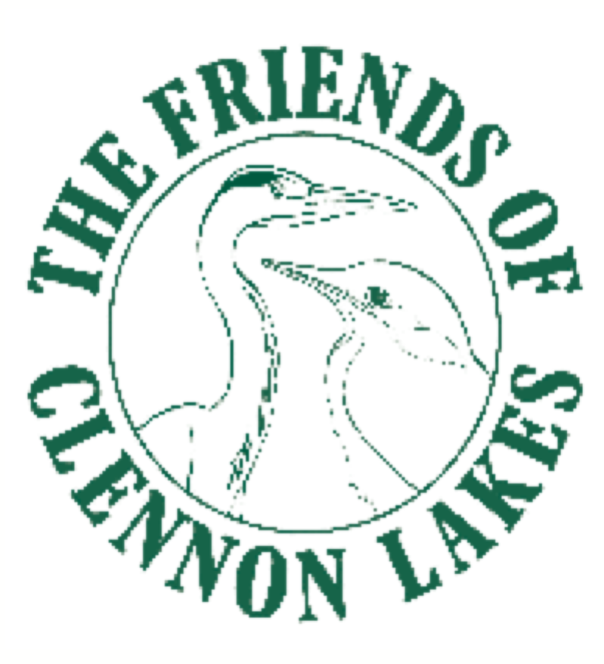

Membership Form

Annual minimum membership fee: £2.00 per person

£3.00 family (2 adults + children)

renewal date is 1st January each year

Name: ...................................................................................

Address: ...............................................................................

..............................................................................................

.............................................Post Code: ..............................

Phone No. ............................................................................

e-mail address .....................................................................

A copy of Friends of Clennon Lakes (FoCL) Constitution can be obtained from the Secretary.
All data held is purely for FoCL & will not be passed on to any third party.
Contact Details: Secretary: Duncan Macdonald
e-mail: Clennon-Lakes@Virginmedia.com
M: 07493 102073
Site Working & Maintenance Safety Notice:
- Never work alone
- Never enter the water
- Use safety equipment when necessary
- Only use mechanical equipment if suitably trained
- Children U16 must be accompanied by a parent/guardian member at all times
The committee take no responsibility for any loss or injury sustained by members engaged in site working or maintenance at Clennon Lakes.

Please return completed form & membership fee to The Treasurer: Teresa Macdonald, 2 Osney Gardens, Paignton, Devon. TQ4 5HB (cheques payable to “Friends of Clennon Lakes”)

